# P1

1. A to S: Source: 1467, Dest: 23
2. B to S: Source: 1510, Dest: 23
3. S to A: Source: 23, Dest: 1467
4. S to B: Source: 23, Dest: 1510
5. Yes, there’s nothing that stops them from being the same information. There is no relationship between port numbers on different hosts.
6. No, The ports are unique to their processes.

# P2

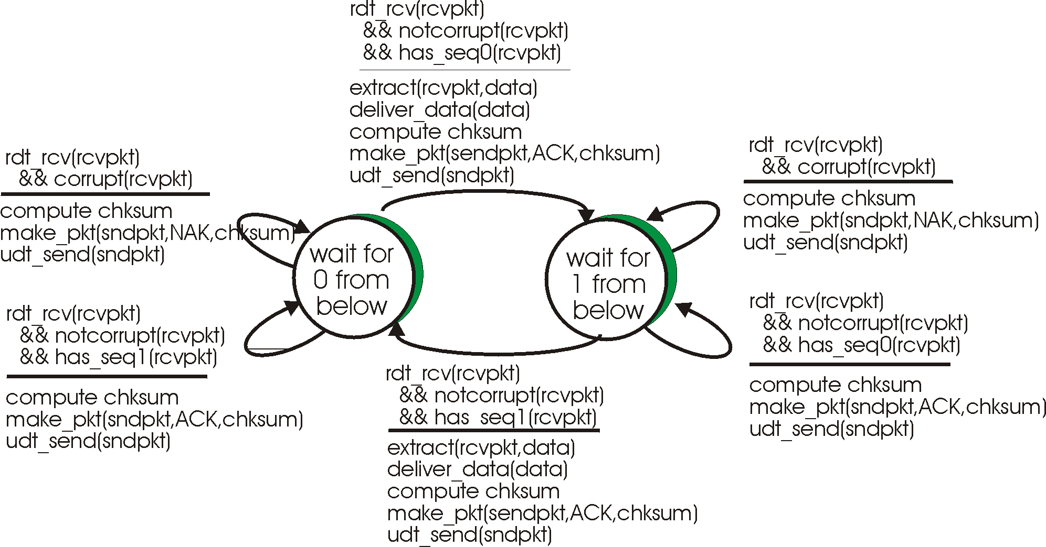

# P3